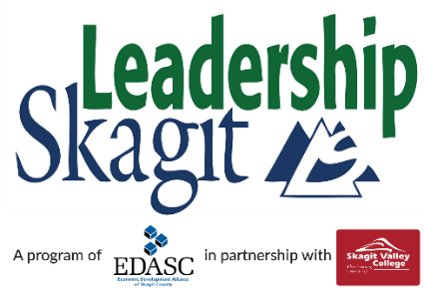 Class of 2022 Schedule

Beginning Your Journey & Welcome Reception | Friday, September 10, 2021
Leadership Retreat | Wednesday-Thursday,  September 22-23, 2021
Ecology Skagit | Friday, October 15, 2021
A Sense of Place | Friday, November 12, 2021
Communicating as a Leader | Friday, December 10, 2021
Building a Healthy Community | Friday, January 14, 2022
Law & Justice | Friday, February 4, 2022
Economic Vitality | Friday, March 11, 2022
Community Services & Stewardship  Step Up Conference for Racial Equity | Friday, April 15, 2022  April-May TBD - 2022
Arts & Culture | Friday, May 13, 2022
Claim Your Leadership Challenge Retreat | Wednesday-Thursday, May 25-26, 2022
Graduation Events
Project Presentation Rehearsals | Thursday, June 2, 2022 (2 hours)
Project Presentations | Tuesday, June 7, 2022 (1/2-day)
Graduation Ceremony & Banquet | Thursday, June 9, 2022 (3-hour evening event)
Contact mary@skagit.org for more information

