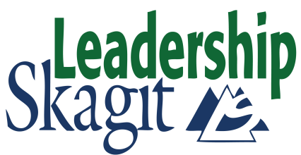
Class of 2021 Schedule
Kick-Off
Friday, September 11, 2020 Beginning Your Journey
1 to 7pm & Welcome Reception
Opening Retreat
Wed & Thurs, September 23-24, 2020 Exemplary Leadership Retreat*
(2-day)

Challenge Days (7:30am to 5pm)
- Friday, October 16, 2020 Challenges & Opportunities

- Friday, November 13, 2020 A Sense of Place

- Friday, December 11, 2020 Communicating as a Leader

- Friday, January 15, 2021 Community Services & Stewardship

- Friday, February 5, 2021 Law & Justice

- Friday, March 12, 2021 Economic Vitality

- Friday, April 16, 2021 Building a Healthy Community

- Friday, May 14, 2021 Arts & Culture

Closing Retreat
Wednesday & Thursday, May 26-27, 2021 Challenge of Change Retreat*
(2-day)
Graduation Events
Thursday, June 3, 2021 Project Presentation Rehearsals*
(2 hours per team)
Tuesday, June 8, 2021 Project Presentations*
(½ day)
Wednesday, June 9, 2021 Graduation Ceremony & Banquet*
(3-hour evening event)

*Requirement for Graduation. Contact mary@skagit.org for information

